**ANSWER UNIT 3 COMPUTER APPLICATION PAGE 22**

**A.Find The Answer To These Questions In The Folllowing Text**

1. Artificial intelligence
2. A. Decision Trees

B. Neural Networks

C. Clustering

1. These patterns are known as **rules**
2. Clusters are used when data isn’t labelled in a way that is favourale to mining.
3. All types of data storage,from large data warehouses to smaller desktop databases to flat files.
4. Refining parameters,using other data analysis tools to examine the data,or even scrapping the data if it’s unusable.
5. -Analysing Supreme Court decisions

-Discovering patterns in health care

-Pulling stories about competitors from newswires

-Resolving bottlenecks in production processes

-Analysing sequences in the humans genetic makeup.

**ANSWER UNIT 3 PAGE 23**

**B.1.Math The Term in table a with statments in table b**

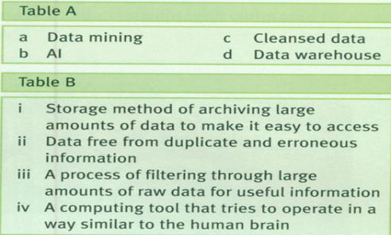

A.Data mining → (iii) A process of filtering through large amounts of raw data for useful information

B.AL → (iv) A computing tool that tries to operate in a way similiar to the human brain

C.Cleansed data → (ii) Data free from duplicate and erroneours information

D.Data warehouse →(i) Storage method of archiving large amounts of data to make it easy to access

**2.Mark the following as true or false**

a. False

b.True

c.True

d.True

e.False

**3.**

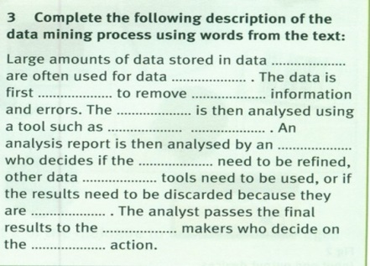

**a. Warehouse**

**b.Mining**

**c.Cleansed**

**d.Duplicate**

**e.Data**

**f.Artificial intelligence**

**g.Analyst**

**h.Parameters**

**i.Analysis**

**j.Unusable**

**k.Decision**

**l.Appropriate**